Ashiya City
From OCTOBER 1st, 2023
○○○○
Neighborhood Association
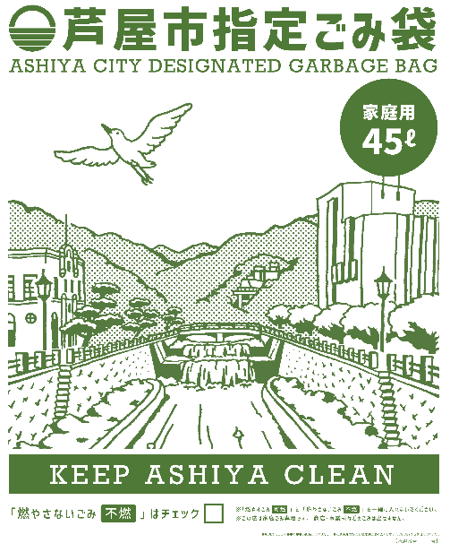
please use a
designated garbage
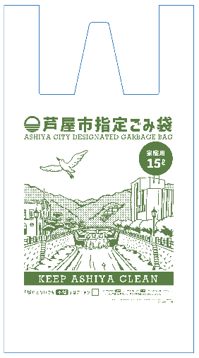
bag for BURNABLE
and OTHER NON-BURNABLE garbage.
*Recyclable paper, PET bottles, cans and glass bottles do not need a designated garbage bag. You may take them out as before in any kind of plastic bag.

